1. Implement chatting application using java socket programming

TCP client – TCP server –

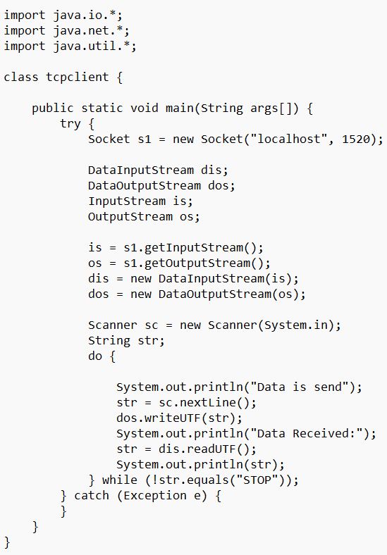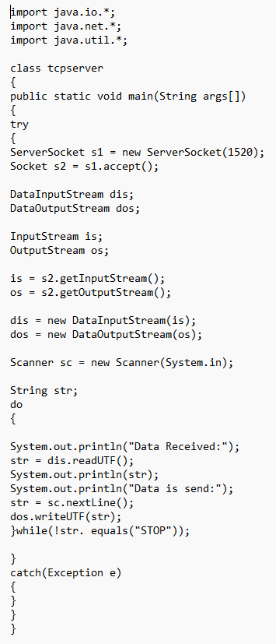

1. Develop a TCP client-server application where the client sends two numbers to the server, and the server returns their sum.

TCP client – TCP server -

